Project Based Learning Report on HOSPITAL MANAGEMENT SYSTEMS of PBL

Submitted to

Department of Computer Science and Engineering Bachelor of Technology

in

Computer Science and Engineering (2021– 2025)

Gopidi Manasa 22R11A0515



Department of Computer Science and Engineering Accredited by NBA

# Geethanjali College of Engineering and Technology (UGC Autonomous)

(Affiliated to J.N.T.U.H, Approved by AICTE, New Delhi) Cheeryal (V), Keesara (M), Medchal.Dist.-501 301.

# August-2023

TABLE OF CONTENTS

|  |  |  |
| --- | --- | --- |
| S.No | Index | Page No. |
| 1 | ABSTRACT | 2 |
| 2 | INTRODUCTION | 3 |
| 3 | OBJECTIVE | 4 |
| 4 | MODULES | 5 |
| 5 | CODE |  |
| 6 | OUTPUT |  |
| 7 | CONCLUSION |  |
| 8 | REFERENCES |  |

1

# ABSTRACT

The Hospital Management System is an integrated software solution designed to address the challenges faced by hospitals and healthcare facilities in managing various administrative, clinical, and financial processes. A Hospital Management System is a system which is used to manage and coordinate all facilities of a hospital. The various functions of a hospital, such as patient care, stock of medications, availability and schedule of doctors, managing appointments and many more can be streamlined and ameliorated by having a dedicated management system. The Hospital Management System contains information on various aspects such as the appointment scheduling process, medical inventory, prices of various surgeries and tests available, and information on all the doctors who work in the hospital. In addition to this, there will be a login system for doctors and patients. Doctors can view details such as their schedules, current roster of patients, status of patients etc. while patients will have access to their history of tests and treatment in the hospital, the medications they are currently using, as well as their current status of care. In this way, the Hospital Management System makes the treatment process much more effective and transparent.

This system aims to streamline and automate the workflow, enhance operational efficiency, improve patient care, and facilitate accurate decision-making.

2

# INTRODUCTION

A [Hospital Management System (HMS](https://datamateindia.com/)) is a hospital information system that is a software solution that helps a hospital or medical care facility to manage its operations. In other words, it is an integrated solution that helps manage hospital resources and functions efficiently by integrating multiple hospital departments into one single network.

The HMS has been increasingly using technology over time to make sure that their processes are streamlined and efficient. This means that one will be able to keep track of all their patients’ records on a single platform so that they are aware of everything from the start to finish.

The HMS helps design a unique and efficient way to organize,plan and implement the management systems. The team has developed HMS with HTML,CSS,Javascript as frontend and the backend is supported by PHP. The HMS is deployed with the help of XAMPP server.

HMS is developed for the user to view the services or log-in to book an appointment including the staff and doctors can also log-in to view their schedules.

The project HMS includes registration of patients,storing their details into the system, and also computerized billing in the pharmacy, and labs. The software has the facility to give a unique id for every patient and stores the details of every patient and the staff automatically. It includes a search facility to know the current status of each room. Users can search for the availability of a doctor and the details of a patient using the id.

The HMS can be entered using a username and password. It is accessible either by an administrator or receptionist. Only they can add data into the database. The data can be retrieved easily. The interface is very user-friendly. The data are well protected for personal use and makes the data processing very fast

3

# OBJECTIVE

* Design a system for better patient care.
* Reduce hospital operating costs.
* Better coordination among the different departments.
* Provide top management a single point of control.

[**Hospital Management System**](http://www.datamateuae.com/)handles activities of major departments in a hospital like:

1. Reception/Front Office
2. Patient management : scheduling, registration and long-term care
3. Patient care and departmental modules : Cardiology, pediatrics, Neurology, radiology and many more.
4. Manage Doctor Schedules: Rounds(In-Patient), Out-patient treatment , Seminars and many more.

4

# MODULES

## MODULE 1: HMS.html

The HMS.html in Fig 1.1 is the main page. The user/staff first views this page and then proceeds to be cognizant of the services offered by the hospital. Here in the navigation bar we have different pages that can be accessed by the user.

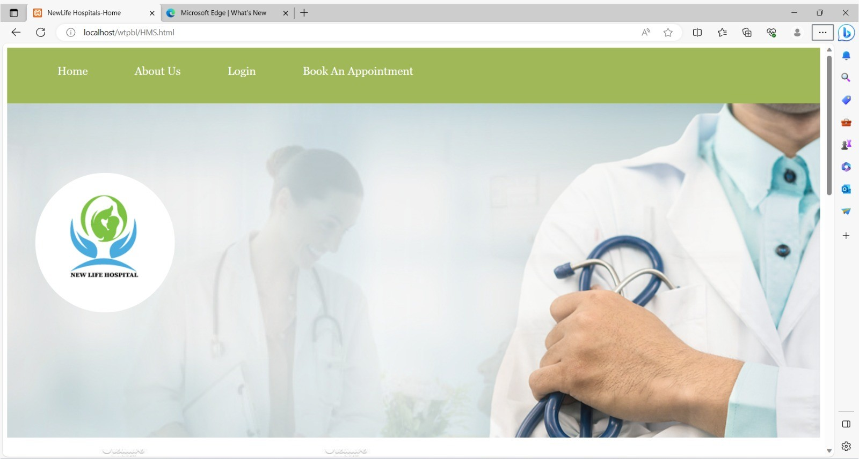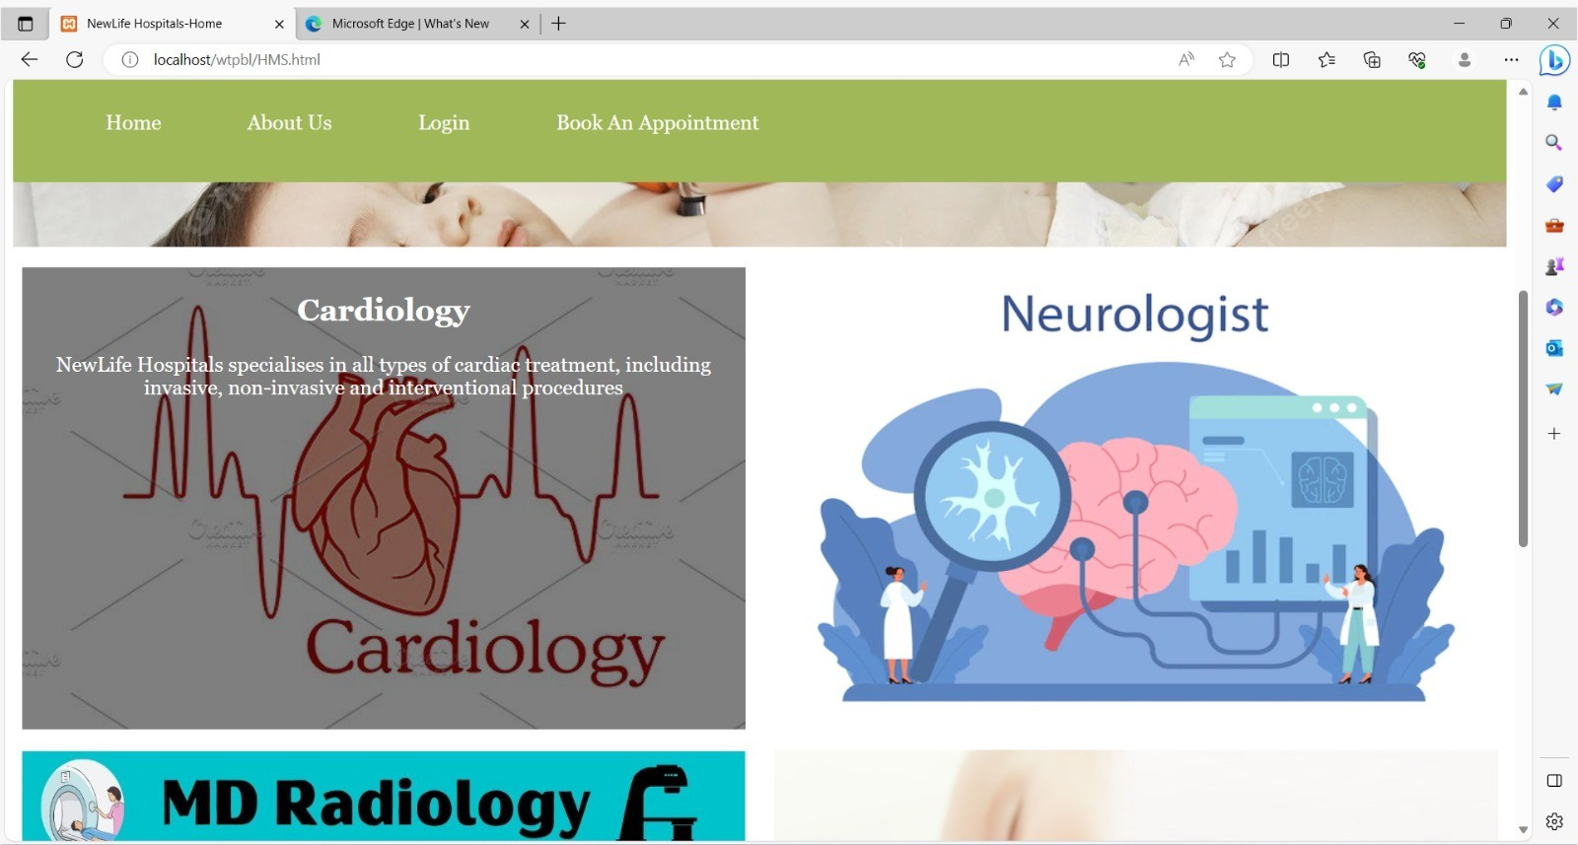

5

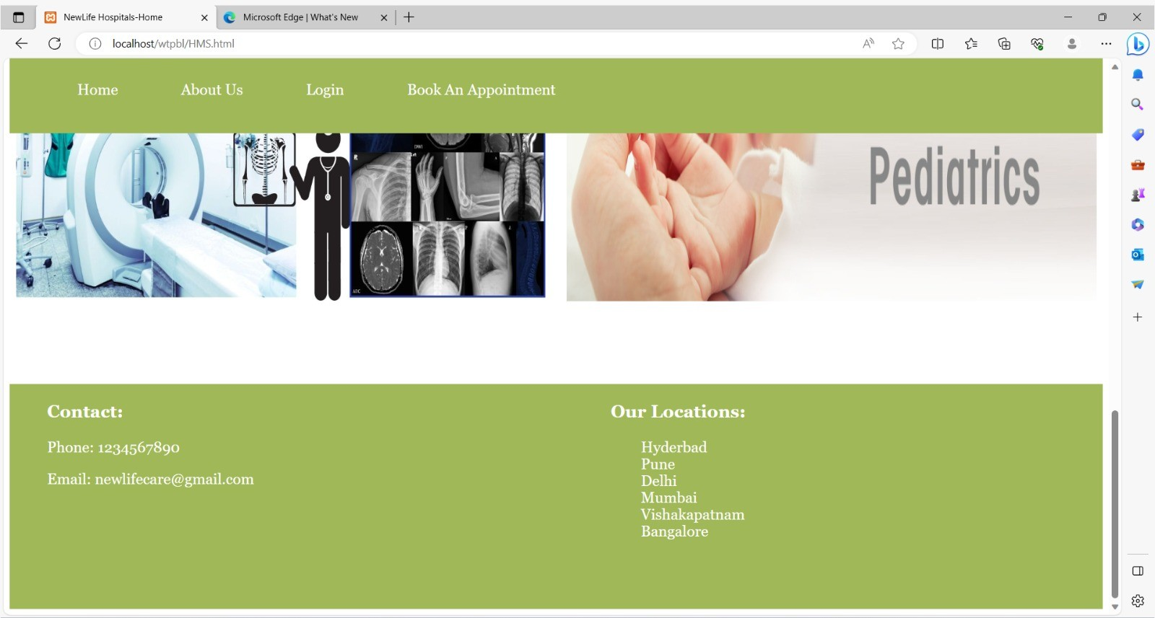

Fig 1.1 ,1.2 ,1.3 HMS.html

## MODULE 2: ABOUT US

About Us in Fig 2.1 page gives details like the motto , services offered and Contact information of the hospital that we can use to approach the team for accessing their services.

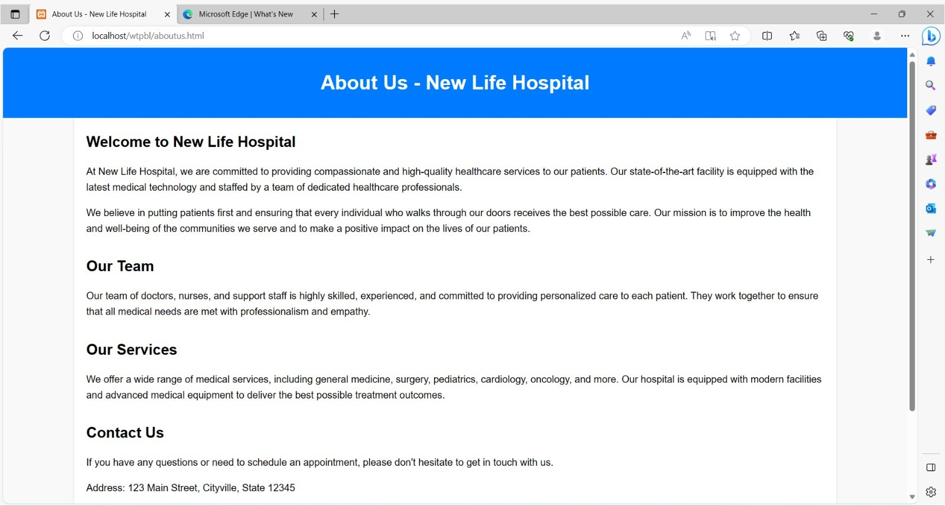

Fig 2.1 About Us 6

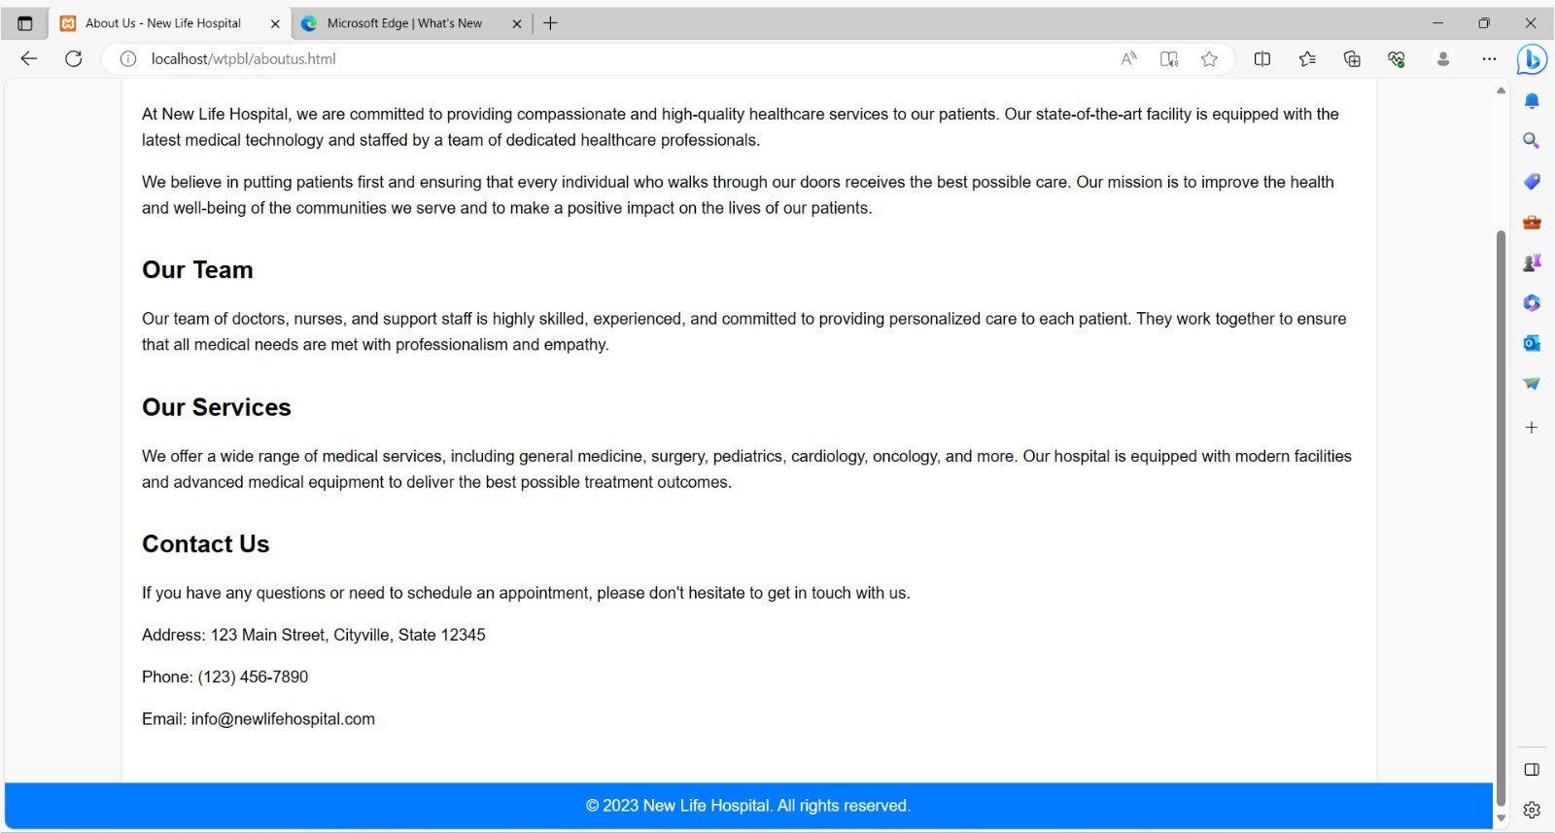

Fig 2.2 About Us

## MODULE 3: LOGIN PAGE

In Fig 3.1 we have a login page that allows login in for both doctors and patients.

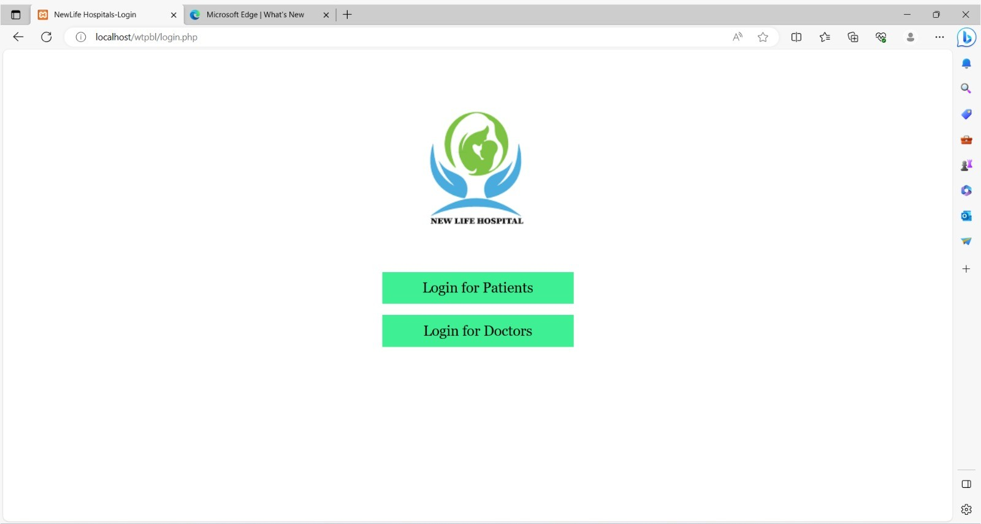

Fig 3.1 Login-in page

7

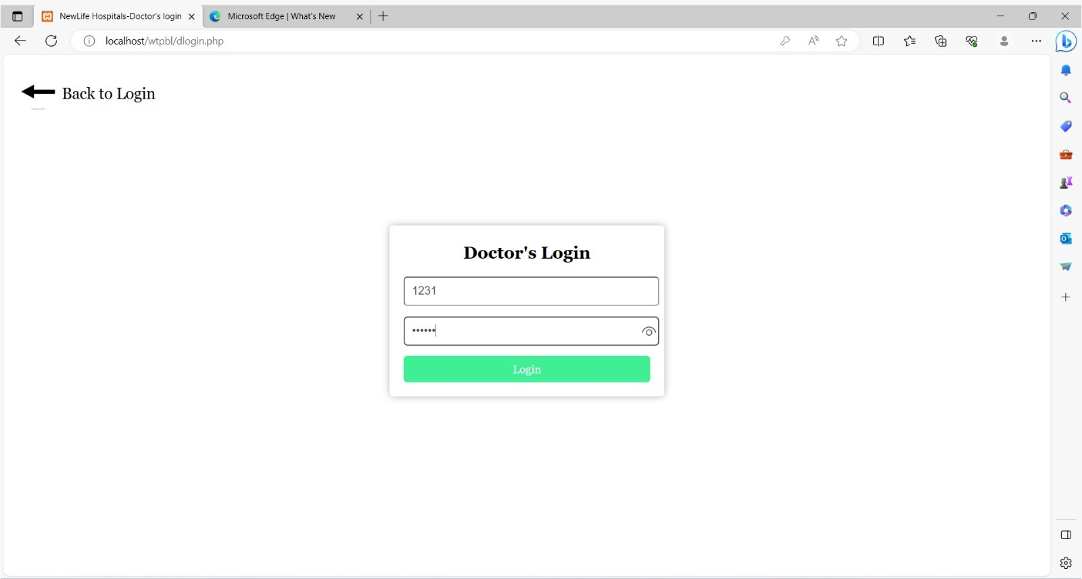

Fig 3.2 Doctor Login

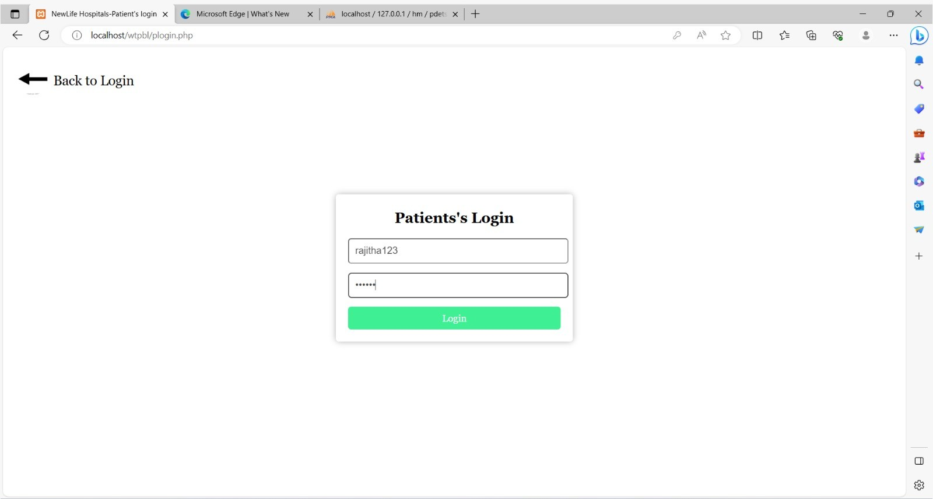

Fig 3.3 Patient Login

8

## MODULE 4: MAKING AN APPOINTMENT

The patient can make an appointment by entering the details. This also works as a page that can gather the details and store it in.

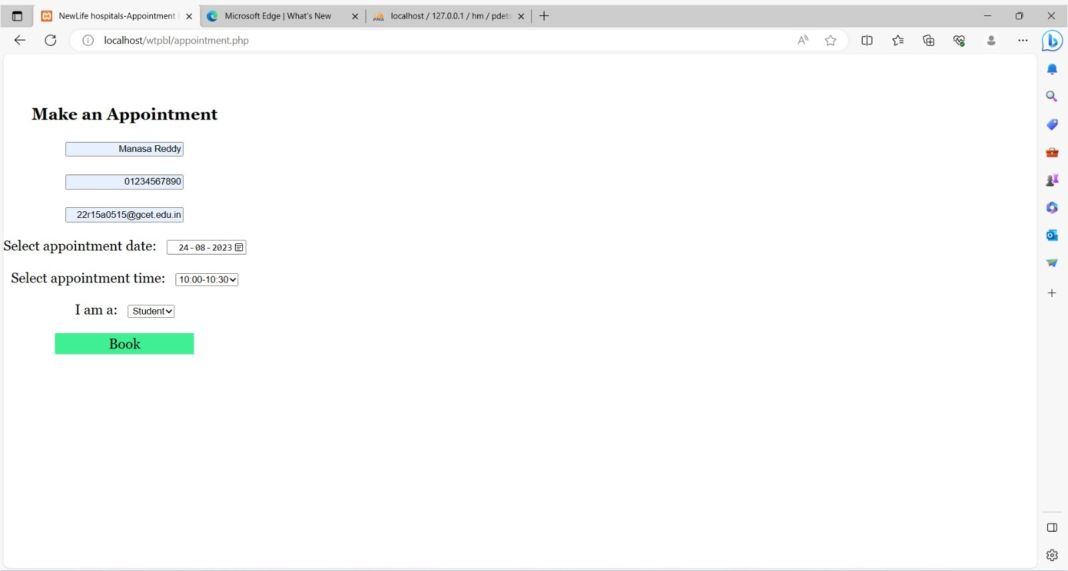

Fig 4.1 The details are stored and saved in the database.

9

# CODE

## HMS.html

<head>

<title>NewLife Hospitals-Home</title>

</head>

<body>

<nav>

<div id="d2"><a href="HMS.html">Home</a>

<a href="aboutus.html">About Us</a>

<a href="login.php">Login</a>

<a href="appointment.php">Book An Appointment</a></div>

</nav> <header>

<img id="d4" src="logo.jpeg" alt="logo" id="logo"></header>

<section id="info">

<img src="i1.jpg" id="d5">

<div id="pd5">

<h2>Cardiology</h2>

<p>NewLife Hospitals specializes in all types of cardiac treatment, including invasive, non-invasive and interventional procedures</p>

</div>

<img src="neurologist.jpg" id="d6">

<div id="pd6">

<h2>Neurology</h2>

<p>The neurology department offers specialized, holistic care for all areas of the nervous system,

including the brain, nerves, muscles and spinal cord. </p>

</div>

<img src="MDobstetrician.jpg" id="d7">

<div id="pd7">

<h2>Radiology</h2>

<p>The radiology department at NewLife Hospitals is equipped with the latest technology and offers a wide range of diagnostic services, including X-ray, CT, MRI, ultrasound and mammography.</p>

</div> <img src="Pediatrics.jpg" id="d8">

<div id="pd8">

<h2>Pediatrics</h2>

<p>Our paediatric department offers a wide range of services for children, including vaccinations, developmental assessments, and treatment for common childhood illnesses.</p>

</div></section><footer>

<div id="d10">

<h3>Contact:</h3>

<p>Phone: 1234567890</p>

<p>Email:

<a [href="mailto:newlifecare@gmail.com">newlifecare@gmail.com</a></p></div>](mailto:newlifecare@gmail.com)

<div id="d12">

<h3>Our Locations:</h3>

<ul>

<li>Hyderbad</li>

<li>Pune</li>

<li>Delhi</li>

<li>Mumbai</li>

<li>Vishakapatnam</li>

<li>Bangalore</li>

</ul>

</div>

</footer>

</body>

</html>

css for hms.html

<!DOCTYPE html>

<html lang="en">

<head>

<title>NewLife Hospitals-Home</title>

<style> body{

font-family: Georgia, 'Times New Roman', Times, serif;

}

nav{

background-color: rgb(160, 184, 88); height: 100px;

width: 100%; position: sticky; top: 0px;

color: white; z-index: 1;

} #d2{

float: left; height: 50px;

margin-left: 50px; margin-top: 30px; font-size: 22 px;

}

#d2>a{ color: white;

text-decoration: none; margin-left: 40px; margin-right: 40px;

font-size: 20px;

} #d3{

float: right; height: 50px; margin-left: 50px; margin-top: 30px;

margin-right: 50px; font-size: 20px;

}

@keyframes change10%

{background-image:url("[https://healthnewshub.org/wp-content/uploads/2019/03/doctors-day.](https://healthnewshub.org/wp-content/uploads/2019/03/doctors-day.jpg) [jpg](https://healthnewshub.org/wp-content/uploads/2019/03/doctors-day.jpg)");}30%{background-image url("<https://img.freepik.com/free-phot>o doctor-with-stethoscope-baby-without

-clothes-examination-by-doctor_1157-46164.jpg?w=2000");}60%{background-image: url("[https://media.istockphoto.com/id/184312691/photo/doctor-and-senior-patient-talking-in-](https://media.istockphoto.com/id/184312691/photo/doctor-and-senior-patient-talking-in-hospital-room.jpg?s=612x612&w=0&k=20&c=ON0IPi-7i54z67g9YPZurbxnOfUcmZIaKMtb0gzsRRI%3D) [hospital-room.jpg?s=612x612&w=0&k=20&c=ON0IPi-7i54z67g9YPZurbxnOfUcmZIaKMt](https://media.istockphoto.com/id/184312691/photo/doctor-and-senior-patient-talking-in-hospital-room.jpg?s=612x612&w=0&k=20&c=ON0IPi-7i54z67g9YPZurbxnOfUcmZIaKMtb0gzsRRI%3D) [b0gzsRRI=](https://media.istockphoto.com/id/184312691/photo/doctor-and-senior-patient-talking-in-hospital-room.jpg?s=612x612&w=0&k=20&c=ON0IPi-7i54z67g9YPZurbxnOfUcmZIaKMtb0gzsRRI%3D)");}100%{background-image: url("<https://healthnewshub.org/> wp-content/ upl oads/2019/03/doctors-day.jpg");}

}

header{ display: block; width: 100%; height: 600px; z-index: 0;

animation: change 20s infinite; background-repeat: no-repeat; background-size: 100%, 500px;

} #d4{

float: center; margin-left: 50px;

margin-right: 25px; margin-top: 125px; width: auto;

height: 250px; border-radius: 50%;

z-index: 1;

}

#info{

width: 100%; height: 880px;

background-color: white; align-items: center;

z-index:0; display: grid;

justify-content: space-evenly; grid-gap: 20px;

margin-top: 20px; margin-bottom: 150px;

}

#d5, #pd5{

grid-column: 1;

grid-row: 1; width: 705px; height: 450px;

}

#d6, #pd6{

grid-column: 2;

grid-row: 1; width: 705px; height: 450px;

}

#d7, #pd7{

grid-column: 1;

grid-row: 2; width: 705px; height: 450px;

}

#d8, #pd8{

grid-column: 2;

grid-row: 2; width: 705px; height: 450px;

}

#pd5, #pd6, #pd7, #pd8{ background-color: rgb(0, 0, 0, 0.5); color: white;

font-size: 20px; text-align: center; opacity:0; transition: 0.5s; padding-left: 10px;

padding-right: 10px; width: 685px;

}

#pd5:hover, #pd6:hover, #pd7:hover, #pd8:hover{ opacity: 1;

} #d11{

grid-column-start:1; grid-column-end: 3;

grid-row:3; height: 50px;

margin-bottom: 100px; background-color: rgba(52, 126, 124, 0.837); font-family: Georgia, 'Times New Roman', Times, serif;

font-size: 20px; color: white; border:0px;

}

footer{

background-color: rgb(160, 184, 88); height: 300px;

width: 100%; color: white; font-size: 20px; text-align: left; display: grid;

} #d10{

grid-column: 1;

grid-row: 1; color: white;

text-decoration: none; margin-left: 50px;

}

#d10>p>a{

text-decoration: none; color: white;

} #d12{

grid-column: 2;

grid-row: 1;

}

#d12>ul{

list-style-type: none;

}

# aboutus.html

<!DOCTYPE html>

<html lang="en">

<head>

<meta charset="UTF-8">

<meta name="viewport" content="width=device-width, initial-scale=1.0">

<title>About Us - New Life Hospital</title>

<style> body {

font-family: Arial, sans-serif; margin: 0;

padding: 0;

line-height: 1.6; background-color: #f9f9f9;

}

.container {

max-width: 1200px; margin: 0 auto; padding: 20px;

}

.header {

background-color: #007BFF; color: #fff;

padding: 10px; text-align: center;

}

.main-content { padding: 20px;

background-color: #fff;

box-shadow: 0 0 5px rgba(0, 0, 0, 0.1);

}

.section-heading { font-size: 24px; font-weight: bold;

margin-bottom: 10px;

}

.section-content { margin-bottom: 30px;

}

.footer {

background-color: #007BFF; color: #fff;

text-align: center; padding: 10px;

}

</style>

</head>

<body>

<div class="header">

<h1>About Us - New Life Hospital</h1>

</div>

<div class="container main-content">

<div class="section-heading">Welcome to New Life Hospital</div>

<div class="section-content">

<p>

At New Life Hospital, we are committed to providing compassionate and high-quality healthcare services to our patients. Our state-of-the-art facility is equipped with the latest medical technology and staffed by a team of dedicated healthcare professionals.

</p>

<p>

We believe in putting patients first and ensuring that every individual who walks through our doors receives the best possible care. Our mission is to improve the health and well-being of the communities we serve and to make a positive impact on the lives of our patients.

</p>

</div>

<div class="section-heading">Our Team</div>

<div class="section-content">

<p>

Our team of doctors, nurses, and support staff is highly skilled, experienced, and committed to providing personalized care to each patient. They work together to ensure that all medical needs are met with professionalism and empathy.

</p>

</div>

<div class="section-heading">Our Services</div>

<div class="section-content">

<p>

We offer a wide range of medical services, including general medicine, surgery, pediatrics, cardiology, oncology, and more. Our hospital is equipped with modern facilities and advanced medical equipment to deliver the best possible treatment outcomes.

</p>

</div>

<div class="section-heading">Contact Us</div>

<div class="section-content">

<p>

If you have any questions or need to schedule an appointment, please don't hesitate to get in touch with us.

</p>

<p>

Address: 123 Main Street, Cityville, State 12345

</p>

<p>

Phone: (123) 456-7890

</p>

<p>

Email: [info@newlifehospital.com](mailto:info@newlifehospital.com)

</p>

</div>

</div>

<div class="footer">

&copy; 2023 New Life Hospital. All rights reserved.

</div>

</body>

</html>

# login.php

<!DOCTYPE html>

<html>

<head>

<title>NewLife Hospitals-Login</title>

<link rel="stylesheet" href="login.css"/>

</head>

<body>

<img id="d4" src="[https://encrypted-tbn0.gstatic](https://encrypted-tbn0.gstatic/) .com/images?q=tbn:ANd9GcSqEP qmPG1 zOwPa6NLzJ6XOKapRIDSdIwLWqQrlfClUMj0e6SXs2_82sGjXoOuKTAmyqQE&usqp=C AU" alt="logo" id="logo">

<button onclick="window.location.href='plogin.php'">Login for Patients</button><br>

<button onclick="window.location.href='dlogin.php'">Login for Doctors</button>

</html>

## appointment.php

<html>

<head>

<title>NewLife hospitals-Appointment Booking</title>

<link rel="stylesheet" href="appointment.css">

<script>

function dispdets()

{

var doc=localStorage.getItem('cons'); document.getElementById("doc").value=doc;

}

</script>

</head>

<body onload="dispdets()">

<section id="d2">

<center>

<h3>Make an Appointment</h3>

<form action="payment.php" method="POST">

<input type="text" name="name" placeholder="Enter Your Name" id="uname" required><br><br>

<input type="text" name="phno" placeholder="Enter Your Phone number" id="phno" required><br><br>

<input type="email" name="email" placeholder="Enter Your Email Id" id="email" required><br><br>

<label for="date">Select appointment date:&nbsp;&nbsp;</label>

<input type="date" id="date" name="date" required><br><br>

<label for="time">Select appointment time:&nbsp;&nbsp;</label>

<select id="time" name="time" required>

<option value="10:00-10:30">10:00-10:30</option>

<option value="10:30-11:00">10:30-11:00</option>

<option value="11:00-11:30">11:00-11:30</option>

<option value="11:30-12:00">11:30-12:00</option>

<option value="12:00-12:30">12:00-12:30</option>

<option value="2:00-2:30">2:00-2:30</option>

<option value="2:30-3:00">2:30-3:00</option>

<option value="3:00-3:30">3:00-3:30</option>

<option value="3:30-4:00">3:30-4:00</option>

</select><br><br>

<label for="status">I am a:&nbsp;&nbsp;</label>

<select name="status" id="status" required>

<option value="student">Student</option>

<option value="teacher">Teacher</option>

<option value="other">Neither</option>

</select><br><br>

<input type="hidden" name="doc" id="doc">

<input type="submit" value="Book" id="b1" name="b1">

</form>

</center>

</section>

</body>

</html>

# OUTPUT

The following is the output for entering correct credentials in login for doctors.

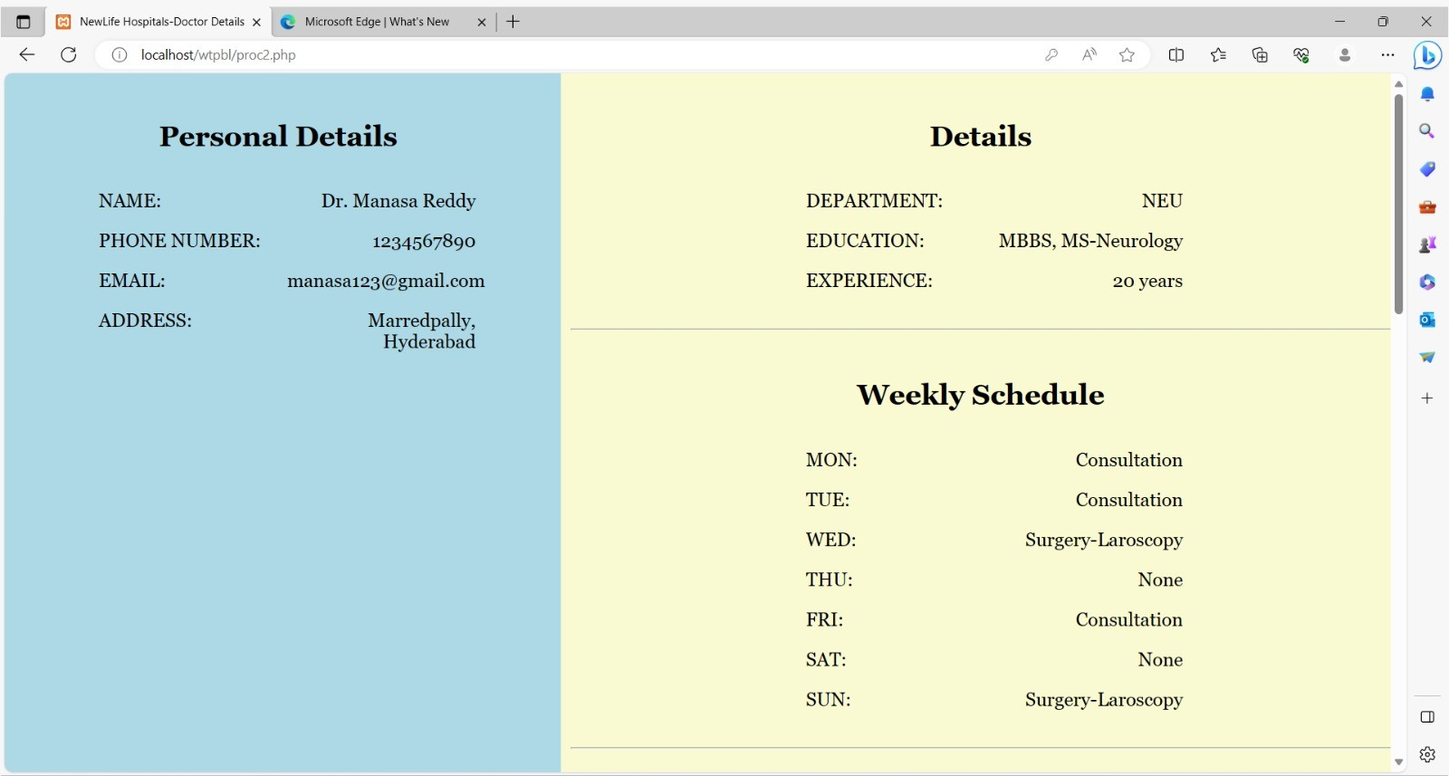

The following is the output for entering correct login credentials for patients.

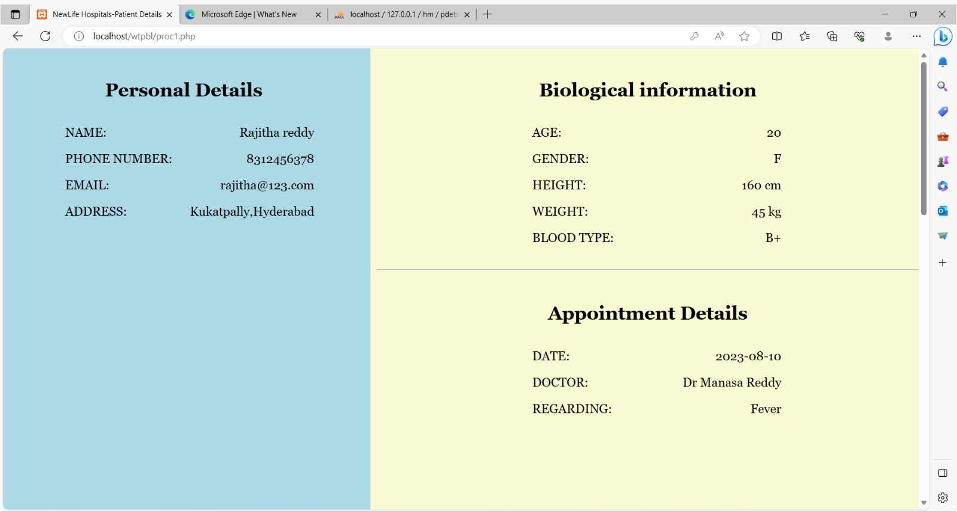

The following is the output for booking an appointment and entering credentials. The database stores the entered details and saves them.

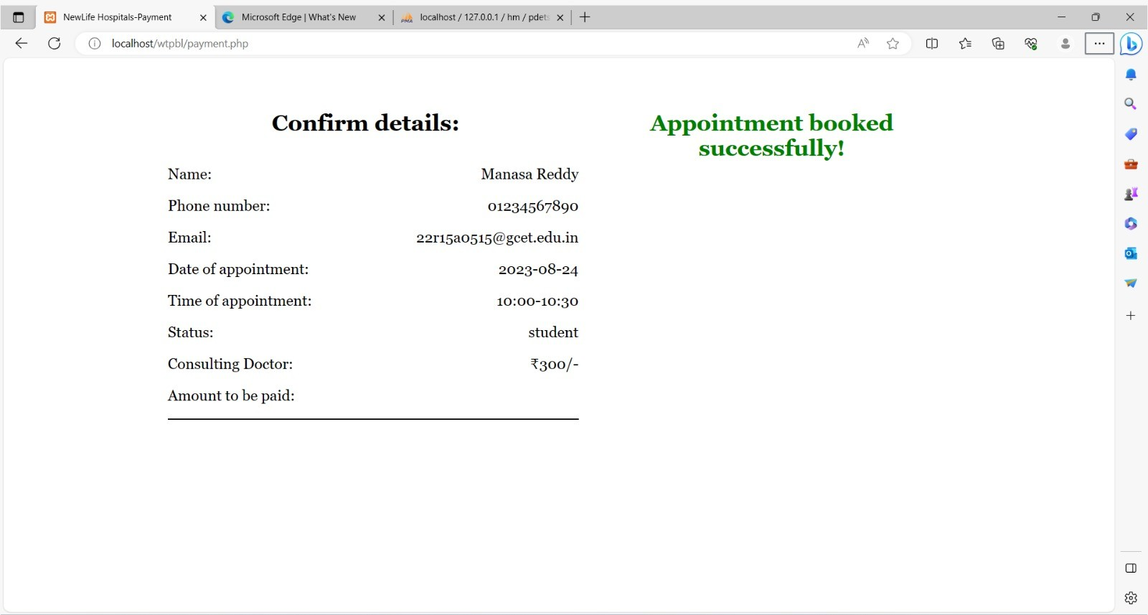

When the doctor logins with wrong credentials then it displays the following.

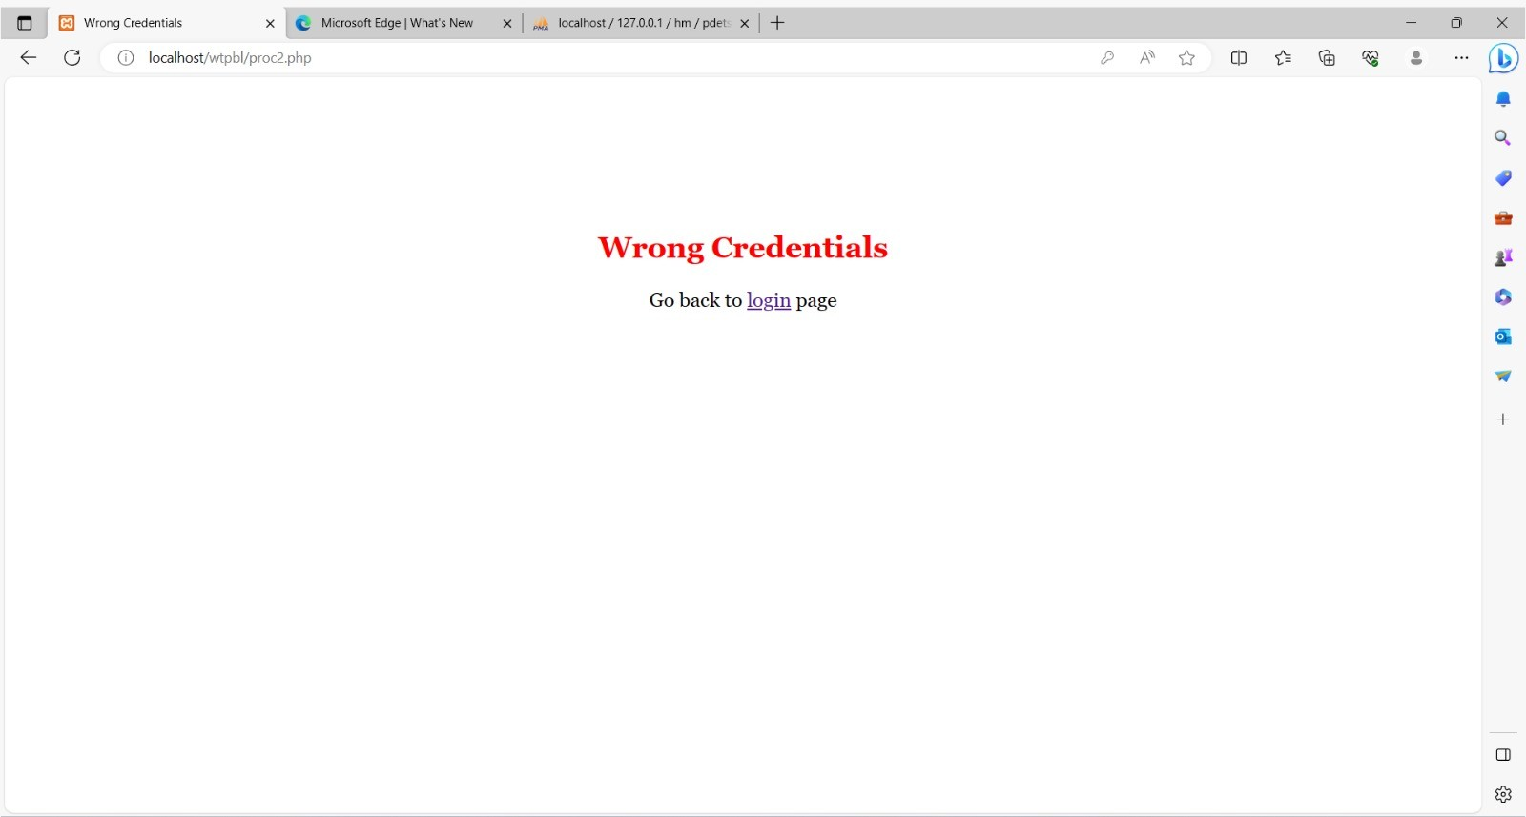

# CONCLUSION

The project Hospital Management Systems takes care of all requirements of a certain number of hospitals and is capable of providing easy and efficient storage of information related to patients that come up to the hospital also for better patient care service.

It displays the schedules of doctors, they can check their day plan. Furthermore physical presence during appointment booking is not required. Here in HMS appointments can be booked from convenience at home.

This can be a powerful tool to help healthcare organizations improve their processes and streamline their operations. It can provide an integrated, comprehensive solution to managing patient records, billing and scheduling, as well as provide real-time insights into hospital performance.

The database stores multiple values that can be used to address and confirm details. It gives many facilities like searching for the details of patients. The system also provides backup as per required.

This hospital management system is quite reliable and is proven on many stages. All the basic requirements of the hospital are provided in order to manage it perfectly and a large amount of data can also be stored .

# REFERENCES

1. W3 Schools - [https://www.w3schools.com/](http://www.w3schools.com/)
2. Javatpoint- [www.javatpoint.com](http://www.javatpoint.com/)
3. Web Dev - https://web.dev/learn/css/
4. For Template reference - FreeCss.com and [www.flux-academy.com](http://www.flux-academy.com/)
5. Youtube- Free CodeCamp.org
6. <https://www.psychonline.in/>